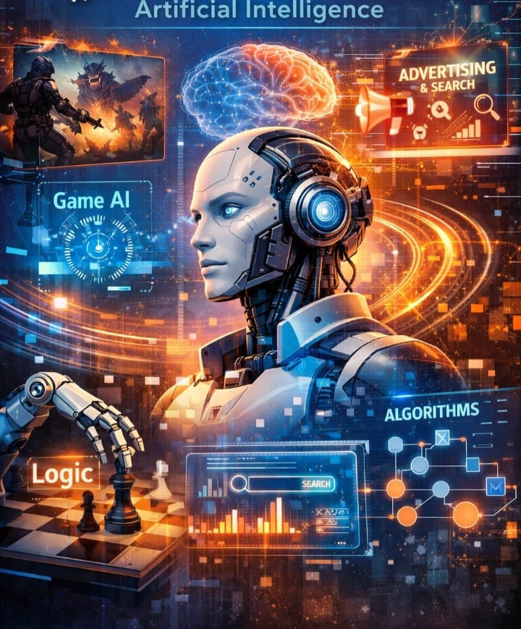

Artificial Intelligence

By Jawad Jammoul

